Boer Goat Breeders’  Association of Australia Ltd  ACN 067 659 081 ABN 840 676 590 81  C/- ABRI  University of New England  Armidale NSW 2351  Tel: 02 6773 5177 Fax: 02 6772 1943  Email: boergoat@abri.une.edu.au  Web: www.australianboergoat.com.au |  | 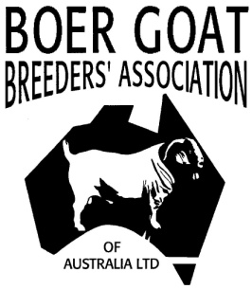
Boer Goats – ‘Meating’ the Market

AGREEMENT FORM LEASED ANIMAL PROGENY

This document is to be used as an agreement between the Owner and the Lessee for the purpose of kid registrations ONLY. The BGBAA cannot become involved in personal disputes.
Completed Forms are to be sent to Registrar.

Lease agreement:

I___________________________________, of Stud name _____________ have leased the following buck/ doe ______________________________ (registration number)

If Doe mated (registration number of buck) _______________________ to:
Name__________________________________________________ of,
Stud name ____________________________ herd prefix___________

Between the dates of ______________ 20____ and _________________ 20___

Checklist (At the time of joining)
Is the Leased Animal currently ACTIVE in BGBAA Herd book Yes No
Is the owner currently a financial member of BGBAA Yes No

___________________________
(signature of owner of animal) date__________

Kidding Information:
All kids conceived during the lease period are to be registered in the Prefix of the:
- Owner of the goat
- Lessee of the goat

Health:
The lessee must provide regular updates and/or photos of the leased goat regarding the goat’s health and living environment to the owner during the lease period: Yes No

Other Stipulations:

Signature of Owner: Date: / / 20

Signature of Lessee: Date: / / 20

